**Assignment -1**

**THE CASE OF 50 STARTUPS**

|  |  |
| --- | --- |
| Student Name | KIRUTHIKA S |
| Student Roll Number | 921319104100 |

**Challenge:** Upload the dataset to Cognos analytics, explore and visualize the dataset

1. **R&D Spending**

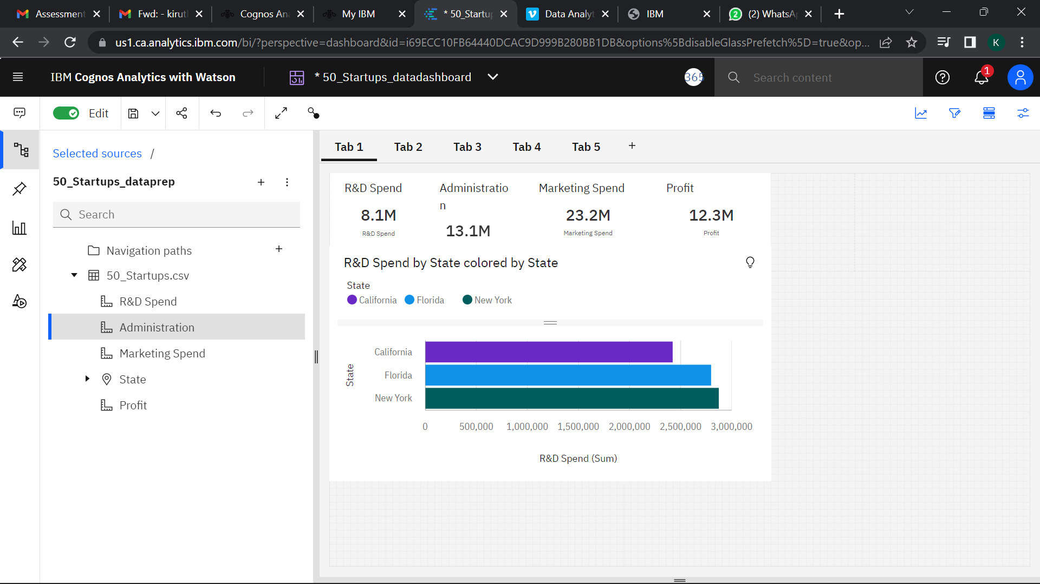

1. **Administration Spending**

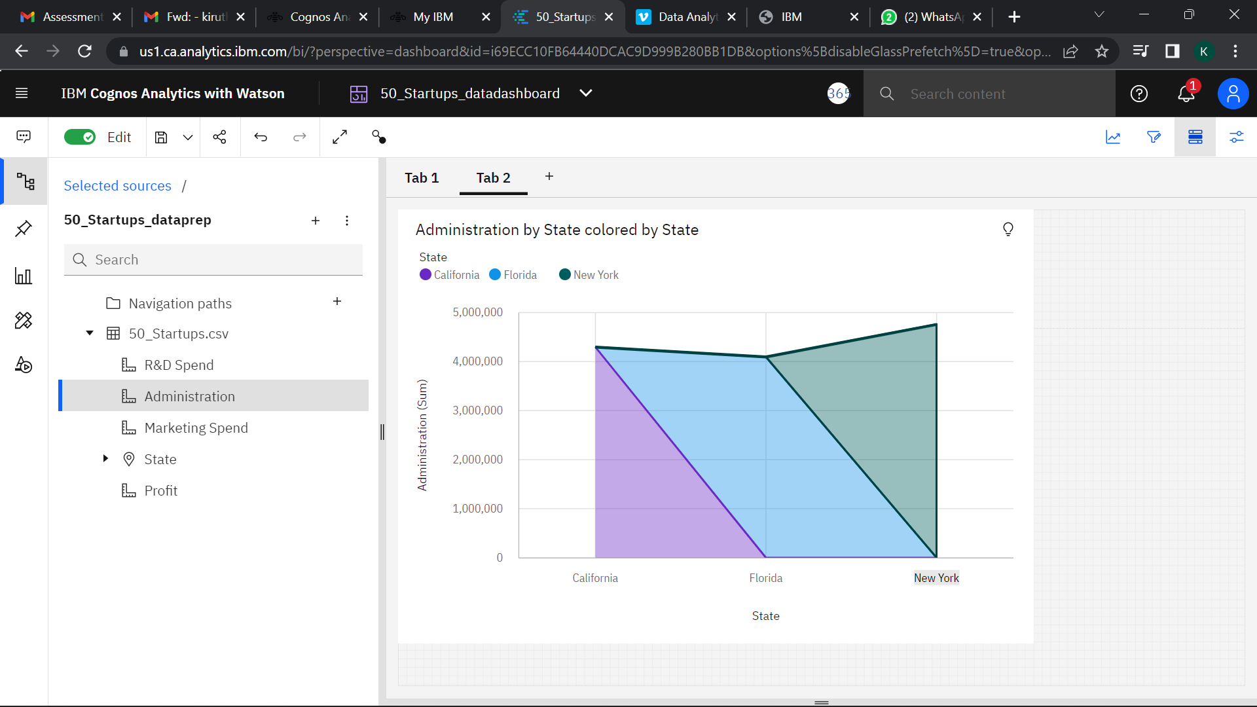

1. **Marketing Spending**

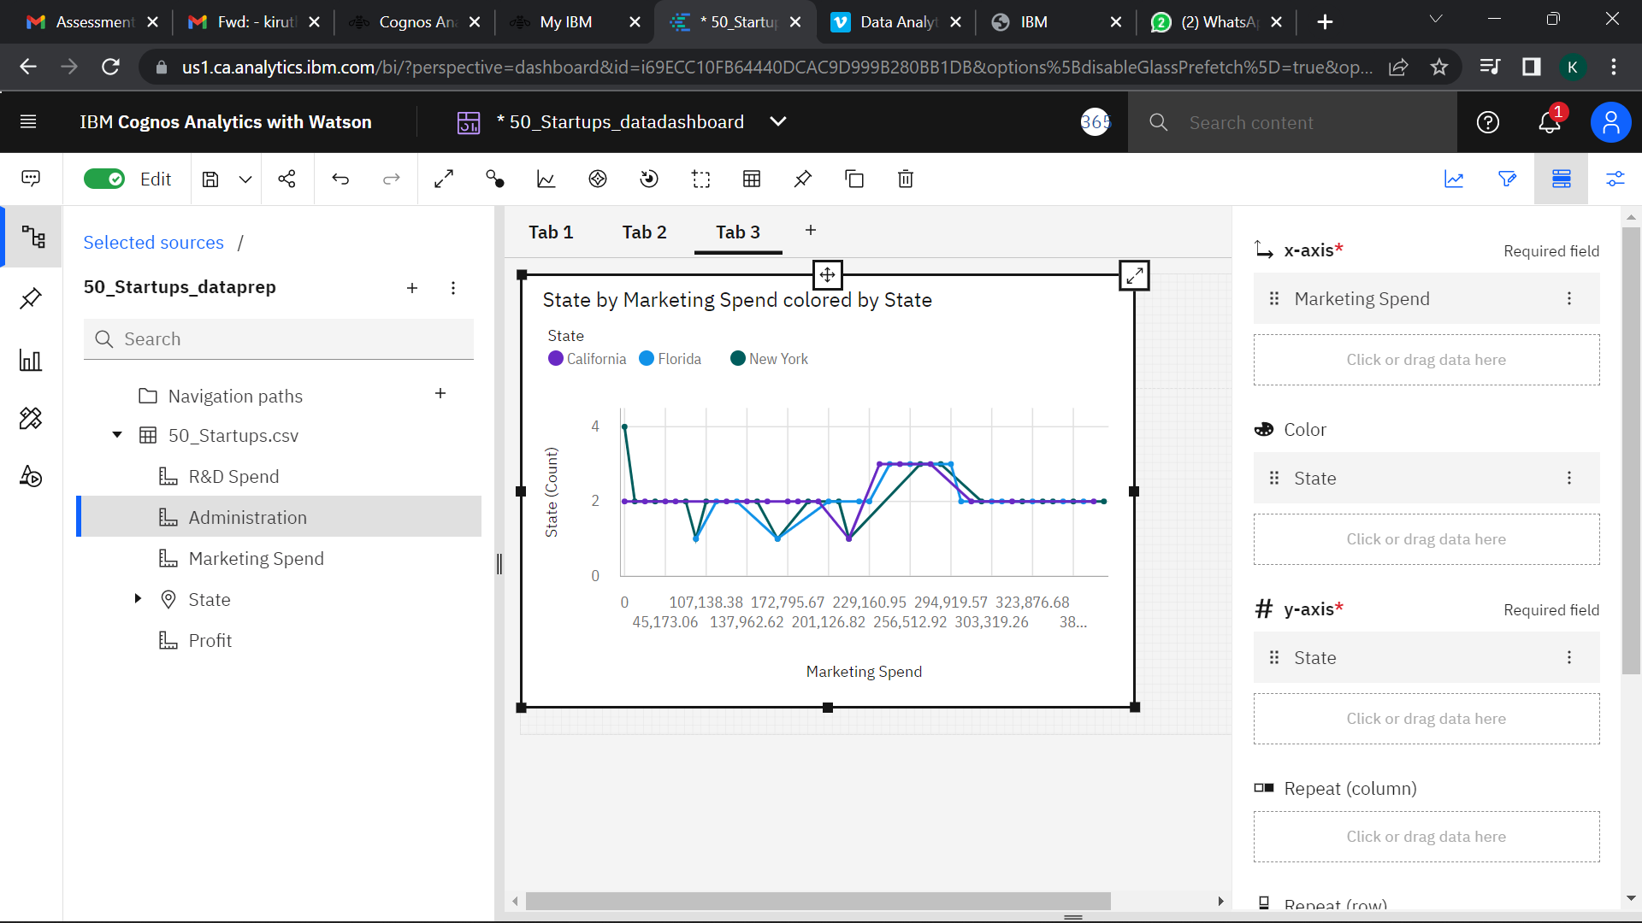

1. **State**

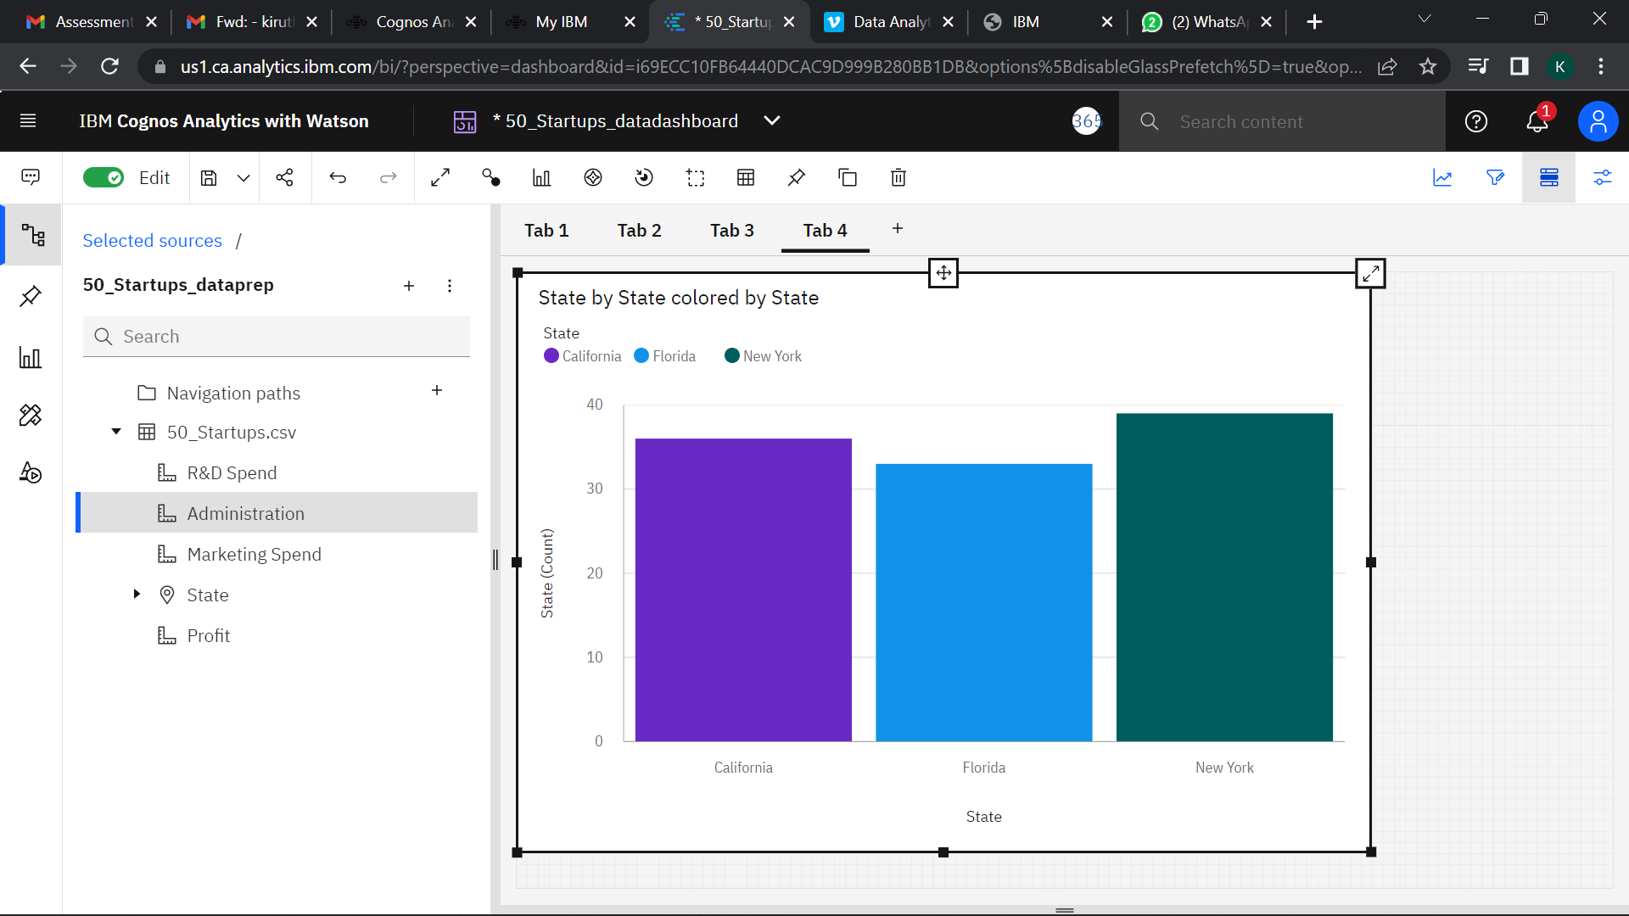

1. **Profit**

